Review Arabic Letters What is the Arabic Alphabet?

The Arabic alphabet consists of 28 letters, reading from right to left.
Shown below are the basic forms of the letters.
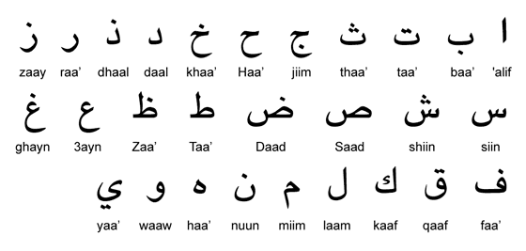
- Arabic doesn't have a case distinction. There are no upper case or lower case letters .
- When combined into words, most letters connect with one another, using slight modifications to the basic letter forms (see more on this below).
- The letters are all consonants, but three of them also represent long vowels.
- In addition to the letters shown above, there are three short vowels, which are added as small marks above or below the consonants. There are also other marks, signifying things like "silent vowel", "doubling of the consonant", etc.
Task: Write down a word that corresponds to each letter above. You might choose a list or a table.

What is Spoken Arabic / the Arabic Dialects?

Souq al-Hamidiye is the old bazaar in the heart of Damascus, Syria.
Spoken Arabic (also called "Colloquial Arabic", or simply "Arabic Dialects" ) differs from Modern Standard Arabic in the following:
- The grammatical structure is simpler.
- Some letters are pronounced differently, and pronunciation also differs between dialects.
- Some words and expressions are more or less unique to their respective dialects.
- Spoken Arabic only occurs in written form when a humorist or popular touch is desired.
- The vocabulary and style are more casual. Slang words and expressions are used that don't have equivalents in Modern Standard Arabic.

How many Arabic dialects are there?
Spoken Arabic can be broadly categorized into the following, main dialect groups:
- North African Arabic (Morocco, Algeria, Tunisia and Libya),
- Hassaniya Arabic (Mauritania),
- Egyptian Arabic,
- Levantine Arabic (Lebanon, Syria, Jordan and Palestine),
- Iraqi Arabic,
- Gulf Arabic (Kuwait, Bahrain, Qatar, the U.A.E. and Oman).
- Hejazi Arabic (Western Saudi Arabia)
- Najdi Arabic (Central Saudi Arabia).
- Yemeni Arabic (Yemen & southwestern Saudi Arabia).
How big differences are there between the Arabic dialects?
- Differences between dialects of the Middle East (Egypt, the Levant, Iraq and the Gulf) are small enough to enable Arabs of different nationalities to understand one another fairly well.
- North African dialects are more unique in structure and vocabulary, and can be a real challenge to understand, even to Arabs of the Middle East.
- Within the main dialect groups, there are regional sub-dialects. Like in other parts of the world, there are differences between the city language and the provincial dialects.
- The most widely understood dialects are Egyptian and Levantine Arabic. The Egyptian media industry has traditionally played a dominant in the Arab world. A huge number of cinema productions, television dramas and comedies have since long familiarized Arab audiences with the Egyptian dialect.
- The satellite television channels have made it easier for other dialects to reach wider audiences. Popular showbiz programs often have Lebanese hosts. This has given the Lebanese dialect something of a fashion status.
So, which type of Arabic would it be better for you to learn?
- If your interest is not limited to one particular country, you should choose Modern Standard Arabic. Once you have basic knowledge of Modern Standard Arabic, learning a dialect becomes an easy task. With myEasyArabic.com, learning Arabic becomes easy and enjoyable, so give it a try and start learning Arabic here.
- Learning to read, write and speak Modern Standard Arabic, and later learning the basics of a dialect, is the best route to sound knowledge of Arabic.
- Educated Arabs, from the middle class and upwards, are quite comfortable conversing in Modern Standard Arabic. Since this form of Arabic serves as a lingua franca across the Arabic-speaking world, speaking with a Mauritanian or an Omani becomes equally easy.
- The choice of language generally depends on the educational level of the person you are addressing. For instance, ordering a shawarma in the street is best done in the local dialect, and so is grabbing a cab.
- If you are going to spend just a short time in an Arab country, you should try to learn the basics of that country's main dialect. This would help you manage the basic day-to-day routines.
- It should be noted that many Arabs have attitudes towards certain dialects. For example, although held in high esteem in Egypt, the Cairo dialect is often looked upon with amusement by non-Egyptian Arabs.
- Finally, if you know Moroccan or Algerian Arabic, you can't use it in the Middle East (east of Libya), since nobody would understand what you are saying.

Read the following sentence and transliterate and translate it.

Now introduce yourself:

Your task is to look for one phrase or commend in different dialects.

